Inventory tools list
CK 95001 wire cutter 2
Magnusson-torpedo-level-9-225mm 3
Screw drivers 4
Magnusson Flat head VDE Screwdriver SL-5.5mm x 125mm 5
Magnusson torx VDE Screwdriver PZ 2mm x 100mm F2517200 5
Magnusson torx VDE screwdriver screwdriver PZ 1mm x 80mm F-2517200 6
Magnusson flat head VDE screwdriver SL - 4.0mm x 100mm 7
Magnusson flat head VDE screwdriver SL - 2.5mm x 75mm 7
Magnusson 200mm VDE certified Long nose pliers 8
Minotaur VDE Combination Pliers 180mm 9
Magnusson VDE Side cutters 6 ¼ (160MM) 9
Tape measure 10

CK 95001 wire cutter
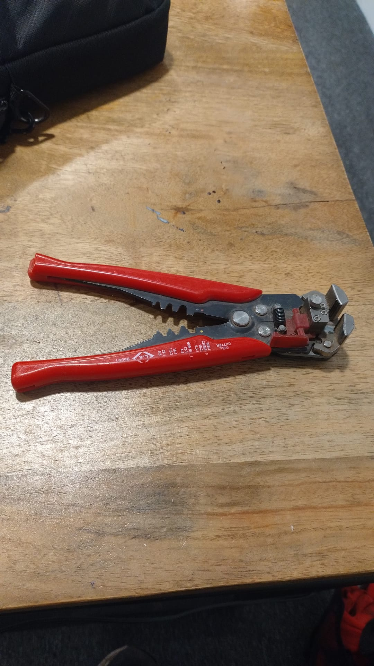

Magnusson-torpedo-level-9-225mm

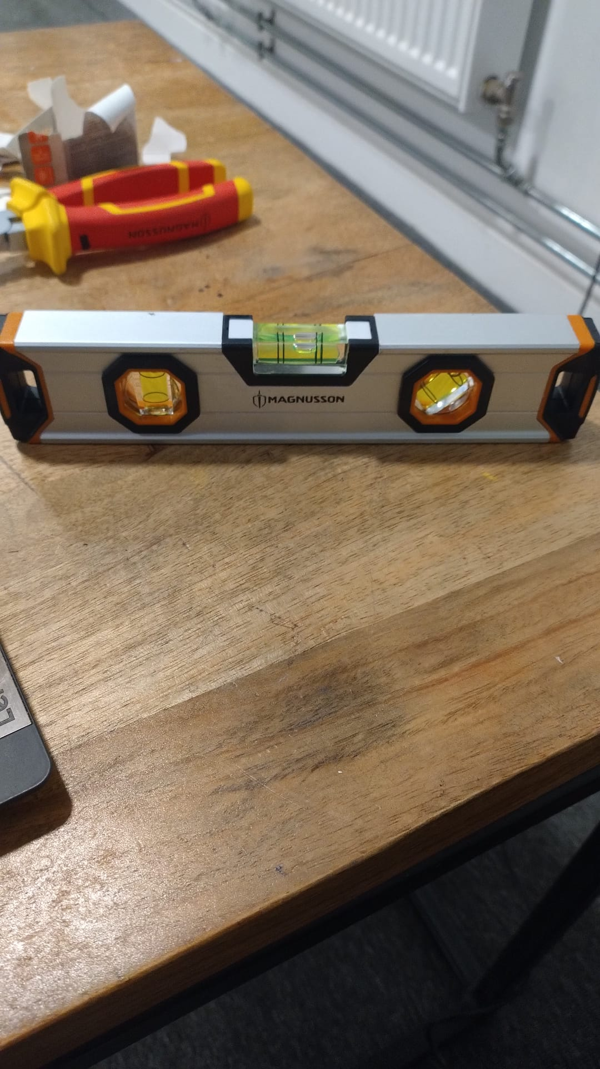

https://www.screwfix.com/p/magnusson-torpedo-level-9-225mm-/8296V?tc=JX5&gclsrc=aw.ds&gad_source=1&gad_campaignid=22605979367&gbraid=0AAAAAD8IdPy4GEH9-f95mG6cPORUkXqh4&gclid=CjwKCAiAz_DIBhBJEiwAVH2XwJW6o_eg8BJ9dBbNqMM4mGeIWqyfXMWpDGekoVLGKvH3tycwCTVR-RoCek8QAvD_BwE

Screw drivers

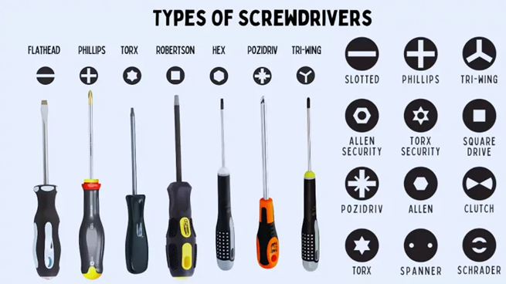

Magnusson Flat head VDE Screwdriver SL-5.5mm x 125mm

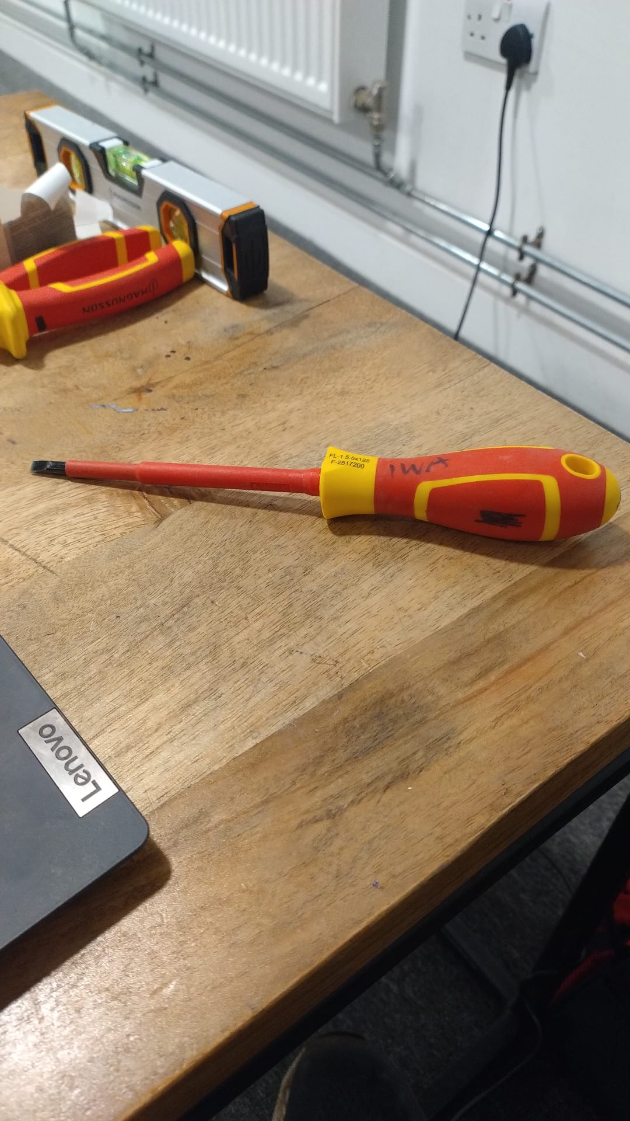

Magnusson torx VDE Screwdriver PZ 2mm x 100mm F2517200

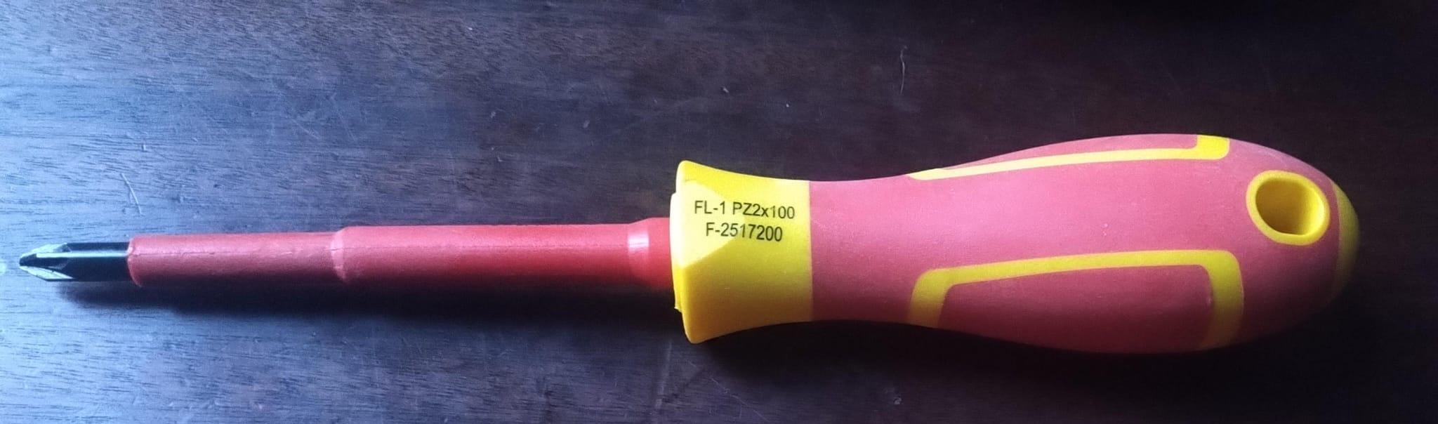

Magnusson torx VDE screwdriver screwdriver PZ 1mm x 80mm F-2517200

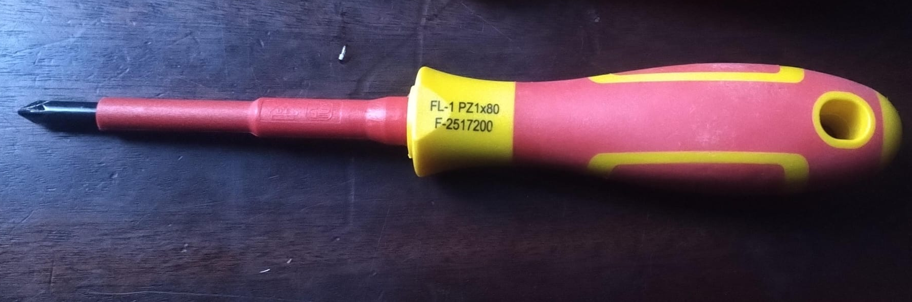

Magnusson flat head VDE screwdriver SL - 4.0mm x 100mm

Magnusson flat head VDE screwdriver SL - 2.5mm x 75mm

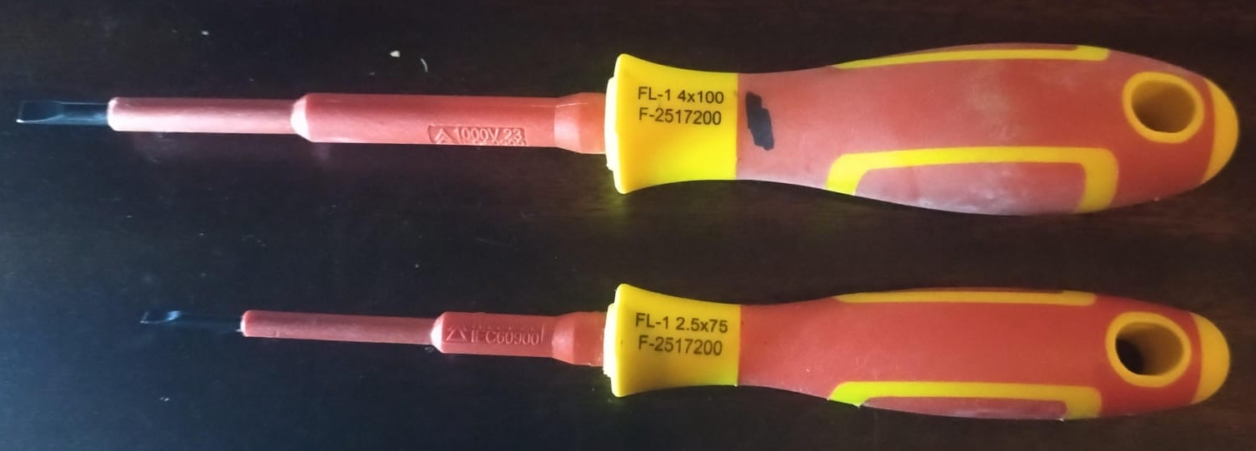

Magnusson 200mm VDE certified Long nose pliers

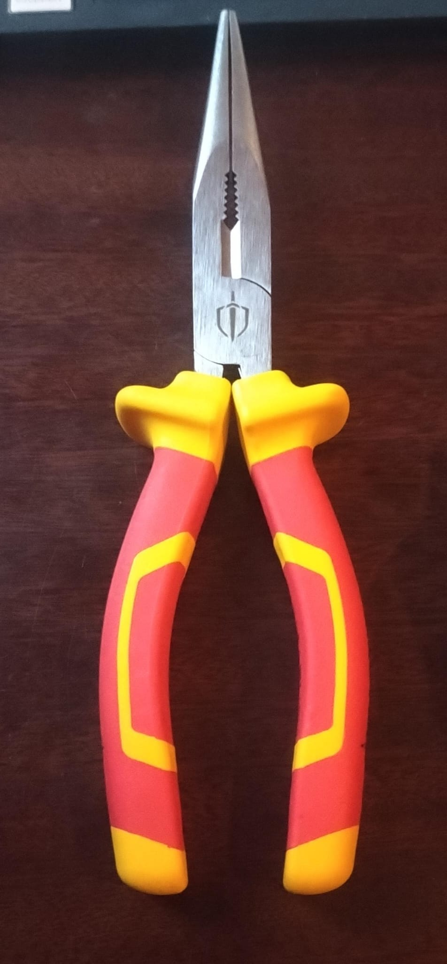

Minotaur VDE Combination Pliers 180mm

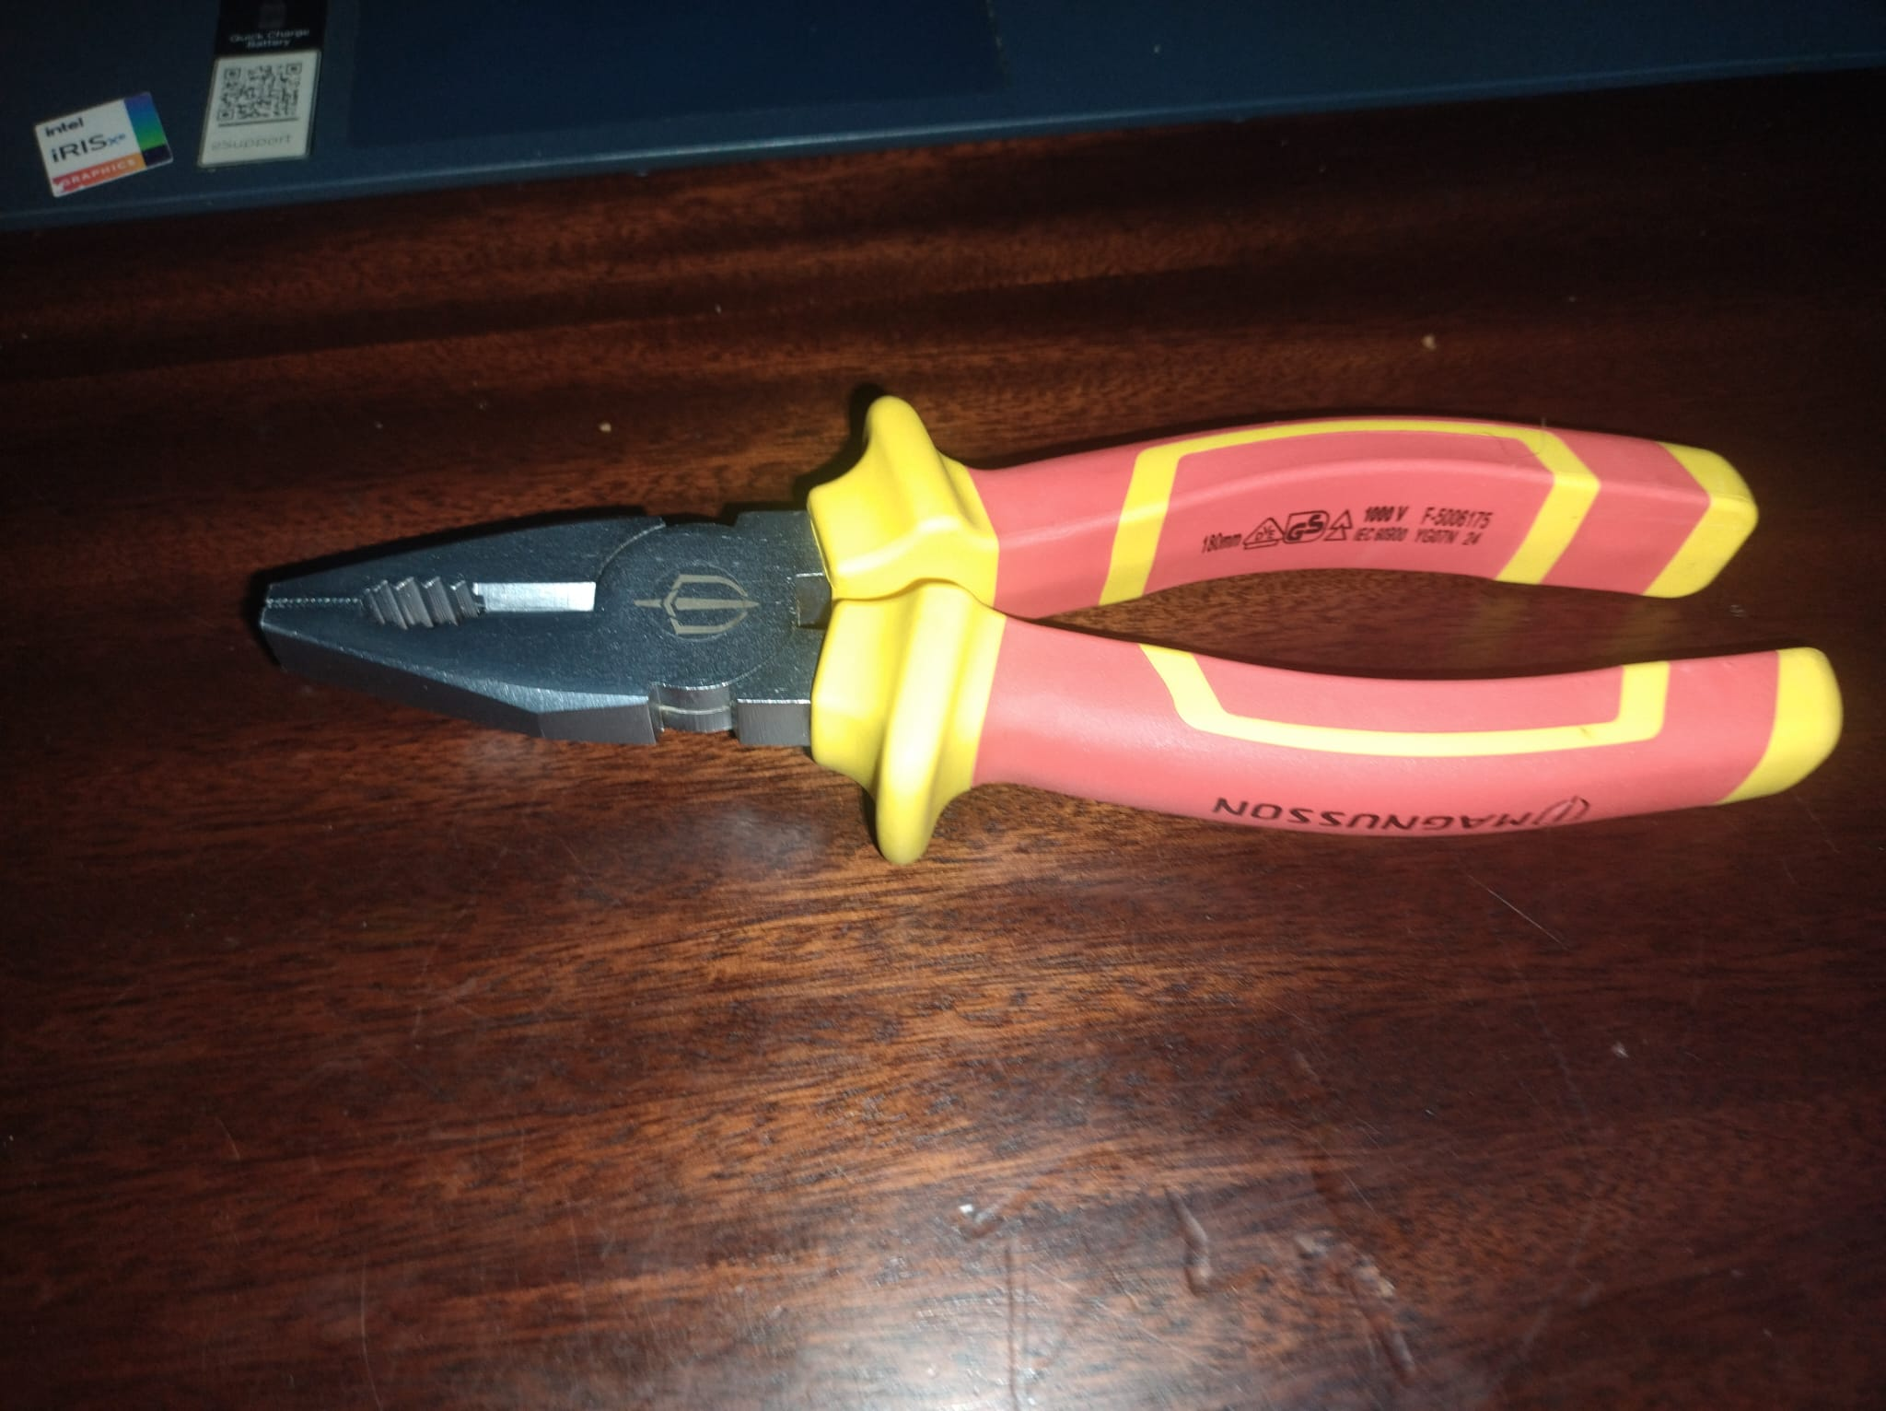

Magnusson VDE Side cutters 6 ¼ (160MM)
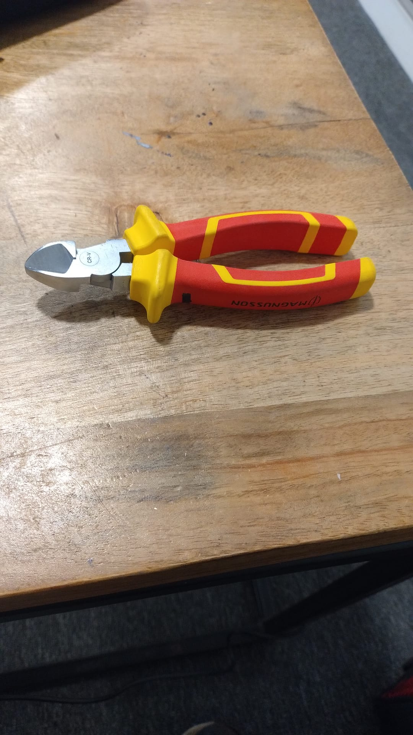

https://www.screwfix.com/p/magnusson-vde-side-cutters-6-1-4-160mm-/5661X?tc=JX5&gclsrc=aw.ds&gad_source=1&gad_campaignid=22599666687&gbraid=0AAAAAD8IdPwslaIYurCWAY6xnUffbjCN5&gclid=CjwKCAiAz_DIBhBJEiwAVH2XwHJHmyh9j5qA4cN2-v4sAcmDhNdTw9udE7ZsZvXImcSgjmSBJKFLZhoC4dMQAvD_BwE

Tape measure
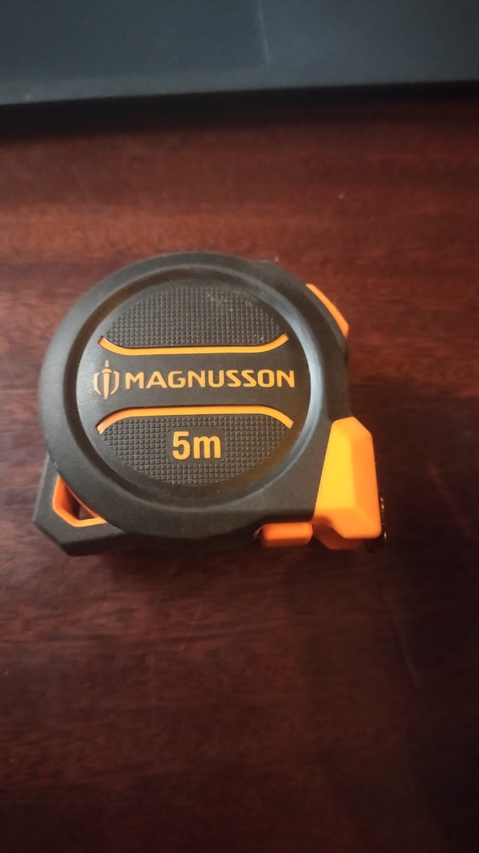

Forge steel Fibreglass shaft claw hammer 16oz (0.45)
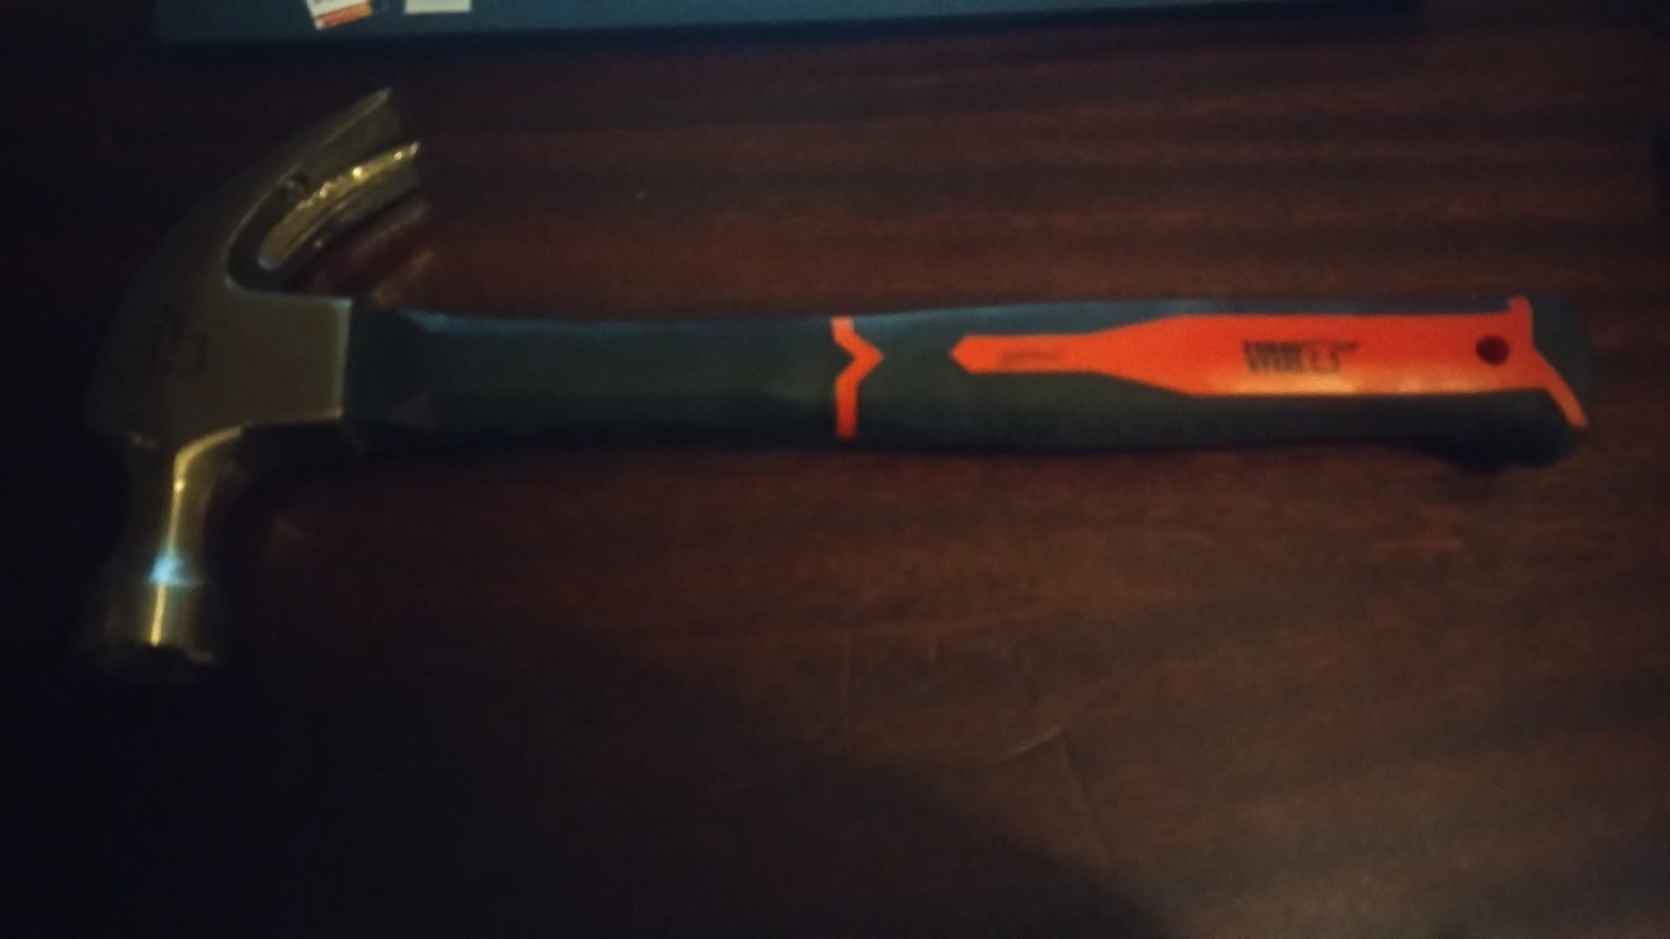

Re-threader tool (M3.5 x 0.6)

